**Graphics and Animation Tools**

**LAB**

**Experiment – 2 Design of Logo using GIMP.**

**Step – 1:**

Open GIMP, go to file → new file → choose 1920x1920 size screen with white as background.

And select the fill with transparency.

**Step – 2:**

Go to image → guide → guide by percent → (horizontal & vertically 50 percent) → OK

**Step – 3:**

Go to View → Enable Snap to Guide and Snap to Canvas edges.

**Step – 4:**

Grab the ellipse select tool, start creating a circle at the center and hold ctrl + shift to create an image covering whole canvas (which creates perfect symmetrical circle.)

Press enter, Go to Edit → fill with background color (white) → Go to Select → NONE.

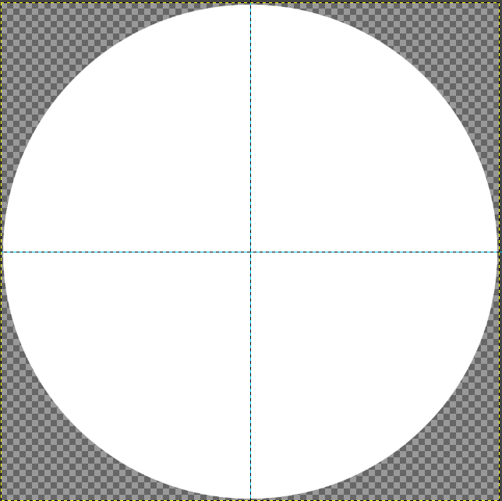

**Step – 5:**

Create new layer (with transparency selected) Repeat the step 4 to create a bit smaller circle of black color.

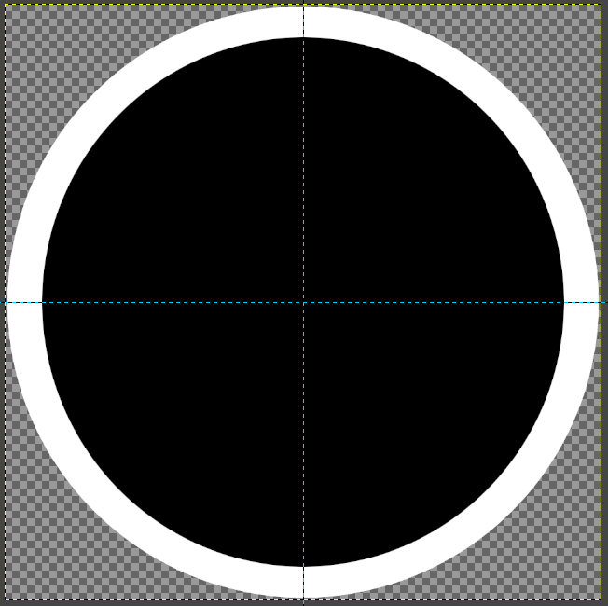

**Step – 6:**

Repeat the step 5 to create a bit smaller circle first white and then black color.

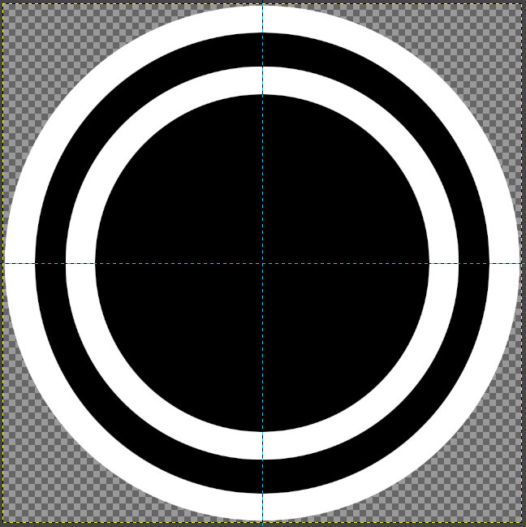

**Step – 7:**

Create new layer (with transparency selected) and select the Text tool (Write your Own Text)

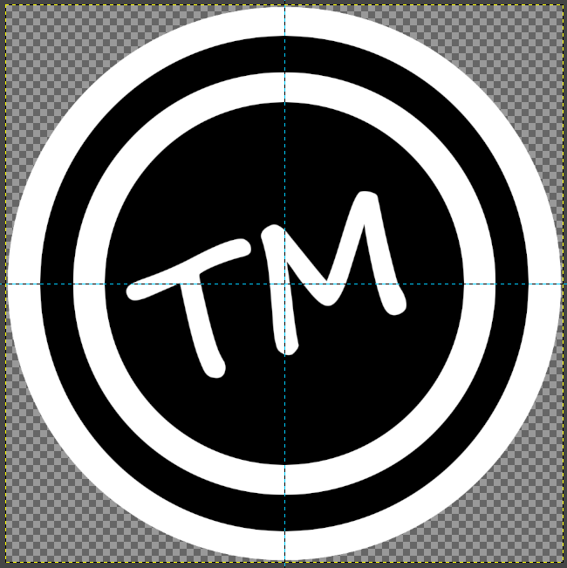

**Step – 8:**

Save the file above in .xcf and .png form.

**Step – 9:**

Now go to File → open → open a background image.



**Step – 10:**

Draw any image on a piece of paper.

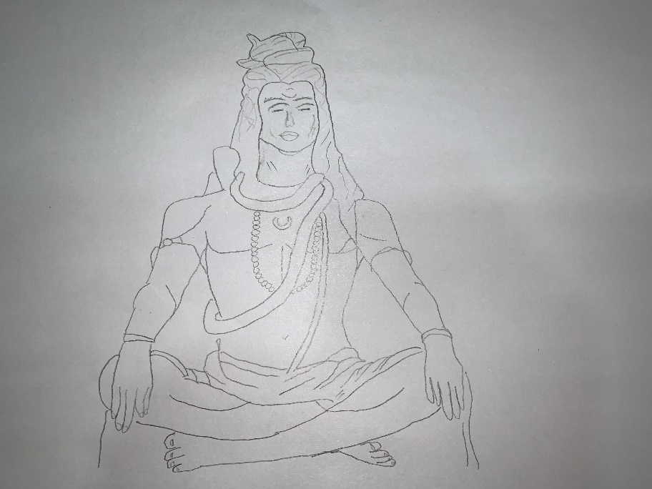

**Step –11:**

Go to Layers → Transparency → Add Alpha channel and then sewlect the eraser toll and erase the part which you don’t want in your image. And save it.

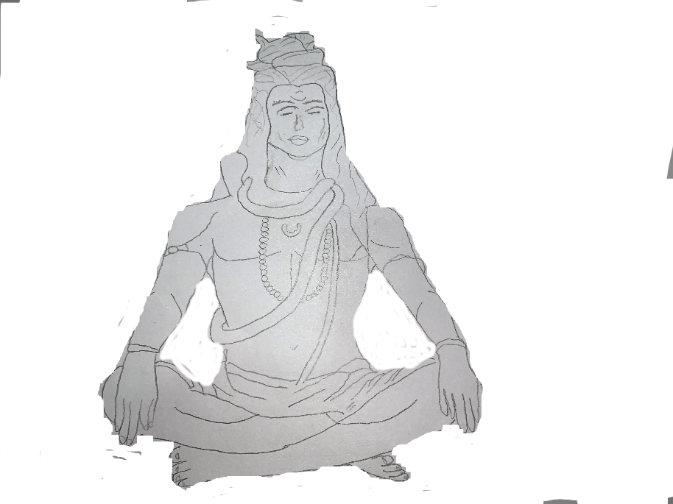

**Step –11:**

Add the cropped image as the layer on the background image. And also add the logo/ trademark created before on the bottom right.

